1Ch 2: Differentiation
Section 1 Day 1: The Derivative and Tangent Line Problem
Objective(s)
Academic…you will be able to: | Social Emotional…you will:
- Find the slope of the tangent line to a curve at a point.  - Use the limit definition to find the derivative of a function.  - Understand the relationship between differentiability and continuity.  - Find the derivative of a function given by a table or graph. | - Respect all in the classroom.  - Be ready to learn and participate.  - Persevere.

Warm Up: Describe the following in all ways possible.
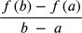

Now, let us think back to the Amplify activity on the introduction to derivatives. This activity started with finding the slope of a ____________ line a few times. Which then led to finding the slope of a _____________ line. The difference between each is for the ___________ line we needed two points where the ____________ line used only one. What concept was needed in order to help us find the slope of the tangent line? Recall this picture…
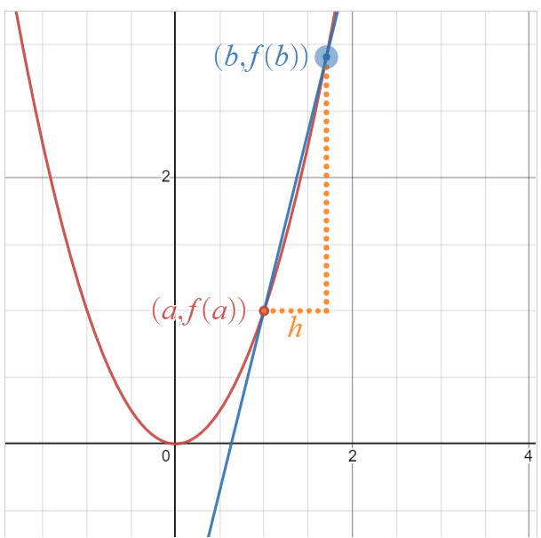 | Therefore…  Slope of secant line:  Slope of tangent line:  (keep in mind what  h means…)

Reference Book Time 🙂
Slope of Secant Line of a curve. |  | Average Rate of Change (AROC)
Slope of a Tangent Line to a curve. | 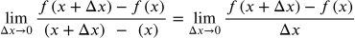 | Instantaneous Rate of Change (IROC)

Example #1 Use the limit definition to find the slope of the tangent line to the curve of f(x) = -5x + 1 at x = 3.

Let’s graph these to show some graphical correlations!
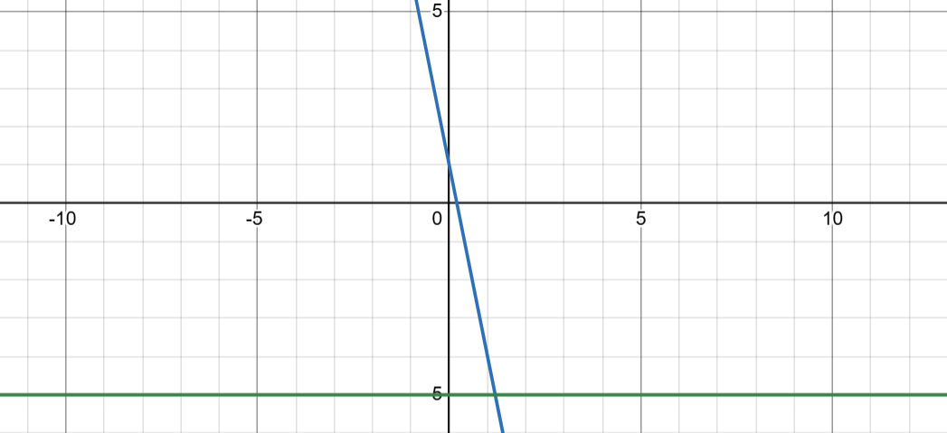
Example #2 Use the definition of the slope of a tangent line to a curve g(x) = x² - 2 at (a) all values of x and then (b) at x = -1 and (c) at x = 3 and (d) the tangent line to g(x) at x = 3.

Let’s look at the graphs!
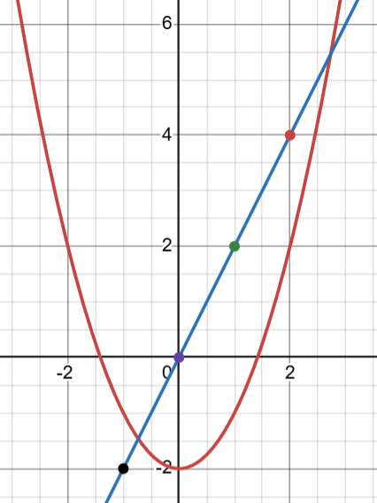

Reference Book Time 🙂
Notation for Slope of a tangent line to a curve & wordings.

f’(x) - “f prime”

- “df dx” - The derivative of the function f with re

IROC - Instantaneous Rate of Change

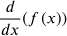 - The derivative of the function f(x) with respect to x.

D_{x}(f) - The derivative of the function f with respect to x.

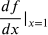 - The derivative of the function f with respect to x at x = 1.

Write the equation of point slope form at x = x₁ in function notation and use the above prime and 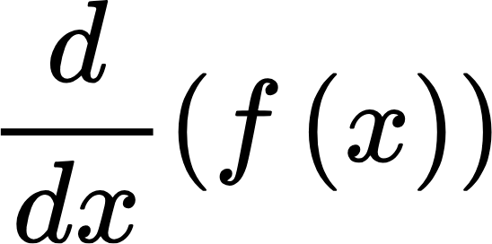notation for slope.

Example #3 Write the equation of the tangent line to h(x) = 4x² - 5x when x = -1. Write it in point slope form first…then find all the parts!

The process of finding the derivative of a function is called differentiation.

Last Example 🙁
Find m’(4) given

Homework 😀
HR: 1, 3, 7, 19, 23, 29

Ch 2: Differentiation
Section 1 Day 2: The Derivative and Tangent Line Problem
Objective(s)
Academic…you will be able to: | Social Emotional…you will:
- Find the slope of the tangent line to a curve at a point.  - Use the limit definition to find the derivative of a function.  - Understand the relationship between differentiability and continuity.  - Find the derivative of a function given by a table or graph. | - Respect all in the classroom.  - Be ready to learn and participate.  - Persevere.

Homework Questions?📝

Example #1 Find given 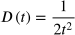. Then find 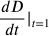 and use this to find the equation of the tangent line to D(t) at t = 1.

Example #2 Is the slope of the tangent line to m(g) = g³ - 4g + 1 larger at g = -3 or g = 2? Show your work to explain.

Example #3 Given the equation of the tangent line to the curve f(x) is y - 7 = -⅔(x + 4) find the following if possible:
- The point of tangency.
- f’(-4)
- f’(7)

Homework 😀
HR: 5, 11, 17, 27, 37

Ch 2: Differentiation
Section 1 Day 3: The Derivative and Tangent Line Problem
Objective(s)
Academic…you will be able to: | Social Emotional…you will:
- Find the slope of the tangent line to a curve at a point.  - Use the limit definition to find the derivative of a function.  - Understand the relationship between differentiability and continuity.  - Find the derivative of a function given by a table or graph. | - Respect all in the classroom.  - Be ready to learn and participate.  - Persevere.

Homework Questions?

So…Let’s talk about differentiability! When we find the derivative of a function this process is called differentiation. Now…not everything is differentiable of course😡

Reference Book Time 🙂
A function f(x) is differentiable at x = c iff
- f(x) is continuous at x = c.
- The left hand derivative at x = c is the same as the right hand derivative at x = c.

Example #1 Let us look at f(x) = | 3x + 1 | on our calculators.
Let us talk about whether or not we believe f(x) is differentiable at all values of x.

Reference Book Time 🙂
When a function is not differentiable
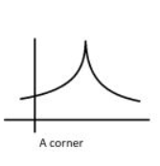  One of the one sided limits heads towards a positive value and the other side heads towards a negative value. | 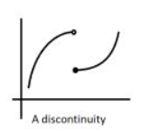  The left hand limit does not equal the right hand limit. | 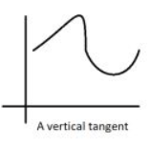  The limit as your approach from the left and right heads towards a vertical line.

Example #2 Determine whether the function f(x) = (x - 2)^{⅕} is differentiable at x = 2.

Example #3 Determine if the following function is differentiable at x = 2. Show your definition/all work!
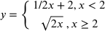

Example #4 Determine the values of a and b which would result in the function f(x) being differentiable at x = -5.
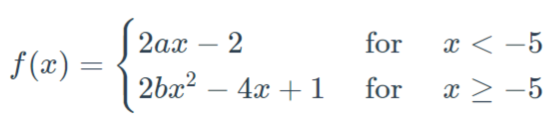

Homework 😀
HR: 45, 53, 71 (use calculator to help), 75, 83, 88

Ch 2: Differentiation
Section 1 Day 4: The Derivative and Tangent Line Problem
Objective(s)
Academic…you will be able to: | Social Emotional…you will:
- Find the slope of the tangent line to a curve at a point.  - Use the limit definition to find the derivative of a function.  - Understand the relationship between differentiability and continuity.  - Find the derivative of a function given by a table or graph. | - Respect all in the classroom.  - Be ready to learn and participate.  - Persevere.

Homework Questions?

Today you will work on graphs through DM! Be sure to ask any question you have while working through the assignment.

Homework 😀
HR: 37 - 43, 51, 52, 87, 89

Students - you don’t have access to these, it is purely for my organization!

Print outs: https://drive.google.com/file/d/1sipl7EjBJC1N8DstR5wMob3G4BmLIlqi/view?usp=drive_link

Student hand outs: https://drive.google.com/file/d/1mdHtXwtkxcohubPHqvjFznNjV88M4Snc/view?usp=drive_link

Ch 2: Differentiation
Section 2 Day 1: Basic Differentiation Rules & Rates of Change
Objective(s)
Academic…you will be able to: | Social Emotional…you will:
- Find the derivative of a function using the Constant Rule.  - Find the derivative of a function using the Power Rule.  - Find the derivative of a function using the Constant Multiple Rule  - Find the derivative of a function using the Sum and Difference Rules  - Find the derivatives of the sine and cosine functions.  - FInd the derivatives of exponential functions.  - Use derivatives to find rates of change. | - Respect all in the classroom.  - Be ready to learn and participate.  - Persevere.

Let’s discuss some rules to make finding derivatives even easier!!!

Constant Rule: The derivative (slope of tangent line) of a constant function is zero. That is, if c is a real number, then
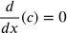
Power Rule: If n is a rational number, then the function f(x) = x^{n} is differentiable and
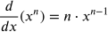
Constant Multiple Rule: If f is a differentiable function and c is a real number, then cf is also differentiable and
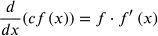
Sum and Difference Rule: The sum (or difference) of two differentiable functions f and g is itself differentiable. Moreover, the derivative of f + g or f - g is the sum (or difference) of the derivatives of f and g.
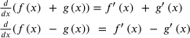
Constant Rule Examples
f(x) = 5, find f’(x). | 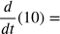 | Find the slope of the tangent line to y = -3.

Power Rule Examples
g(x) = x⁷, find g’(x). | Find the slope of the tangent line to the curve h(x) = x^{e} | 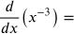

Constant Multiple Rule Examples
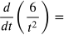 | Find m’(x) given | Find given

Sum and Difference Rule Examples
g(x) = 3x² - ½x⁻³ , find g’(x). | Find. 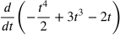 | 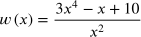
Tangent Lines
- Find the equation of the tangent line of the curve 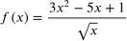at x = 1.

- Determine the x values, if any, at which the graph of the function y = x³ + x has a (1) horizontal tangent line or (2) vertical tangent line.

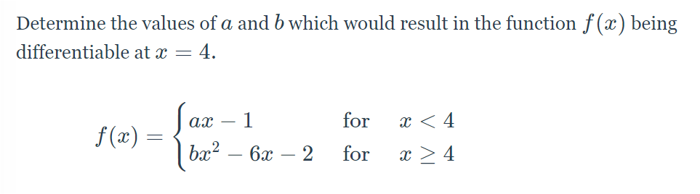

Homework
HR #’s 1 - 17 odd, 27, 29, 33, 41, 43, 57, 65
Ch 2: Differentiation
Section 2 Day 2: Basic Differentiation Rules & Rates of Change
Objective(s)
Academic…you will be able to: | Social Emotional…you will:
- Find the derivative of a function using the Constant Rule.  - Find the derivative of a function using the Power Rule.  - Find the derivative of a function using the Constant Multiple Rule  - Find the derivative of a function using the Sum and Difference Rules  - Find the derivatives of the sine and cosine functions.  - FInd the derivatives of exponential functions.  - Use derivatives to find rates of change. | - Respect all in the classroom.  - Be ready to learn and participate.  - Persevere.
Homework Questions?🤷

Derivatives of Sine and Cosine

Derivative of the Natural Exponential Function

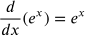

Find the derivative of the following functions.
d(t) = 3cos(t) | 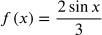
m(n) = 5e^{n} | s(t) = e^{t} - 4t | v(t) = 7e^{t} - cos(t)
Words!!!!! A tennis ball is dropped from a height of 150 feet. The ball’s height, s, at time t, is the position function s = -16t² + 150, where s is measured in feet and t is measured in seconds. Find the average velocity over each of the following intervals.
- [2, 3]

- [2, 2.5]

- [2, 2.1]

- Now, find the instantaneous velocity (rate of change of position with respect to time) at time t = 2 seconds.

REFERENCE BOOK
s(t) = position in terms of time
s’(t) = v(t) = velocity in terms of time [rate of change of position with respect to time]
s’’(t) = v’(t) = a(t) = acceleration in terms of time [rate of change of velocity with respect to time]

More words!!! At time t = 0 seconds, a water balloon is thrown upward from the top of an 80-foot building with an initial velocity of 64 feet per second.
s(t) = -16t² + v₀t + h₀ where v₀ = initial velocity & h₀ = initial height
- How long is the water balloon in the air?

- What is the velocity of the water balloon when it hits the ground?

- What is the maximum height of the water balloon and when did the balloon reach this height?

- What is the acceleration of the water balloon one second after the balloon reaches the maximum height?

Last Example 🙁
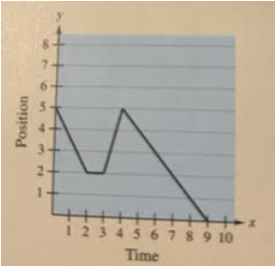 | Given the graph of position vs. time on the left, graph the velocity of the particle.

Problems for Homework tonight and to be worked on in class tomorrow. So - be prepared and either bring your text book to class or make sure you have the pictures on your computers.
HR #’s 19 - 25 odd, 37, 39, 47 - 53 odd, 59, 61, 62, 67, 69, 72, 73 - 77 odd, 95, 99, 101, 115 (homework tonight and finish in the next class)
Reduced work: Pick half the amount - some from each section/set of directions.

Circuit Activity
Ch 2: Differentiation
Section 3 Day 1: Product & Quotient Rules & Higher Order Derivatives
Objective(s)
Academic…you will be able to: | Social Emotional…you will:
- Find the derivative of a function using the Product and Quotient Rules.  - Find the derivative of a trigonometric function.  - Find a higher order derivative. | - Respect all in the classroom.  - Be ready to learn and participate.  - Persevere.

Warm up 🙂
Find the derivative of the following functions:
g(x) = 7x³ - 1 h(x) = 1/(3x) - x m(x) = sin(x) f(x) = 4e^{x} + x^{1/2}

The Product Rule
Let f(x) and g(x) be two differentiable functions.

Example #1. Find the first derivative of h(x) = (3x + 5)(x² - 2x³).
Structure: Does h(x) show a product?
Action: …use the product rule!

Example #2. Find the second derivative of y = x²e^{x}. (Structure…then action!)

Example #3. Find df/dx given f(x) = 4x²sinx - 7cosx.

The Quotient Rule
Let f(x) and g(x) be two differentiable functions.

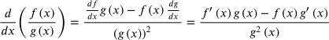

Example 4. Find the derivative of 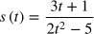. Recall…structure then action!

Example 5. Find the equation of the tangent line to the graph of 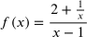 at (2, 5/2).

Example 6. Find the derivative two ways: (1) using the quotient rule, and (2) using the constant multiple rule (rewrite the equation before you derive).
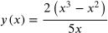

Derivatives of Trigonometric Functions

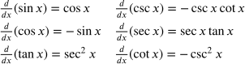
Example 7. Find d/dx(3x² - cscx). Then using the calculator feature (math, nderiv) find d/dx when x = pi/2.

Homework
HR: #’s 1, 5, 9, 13, 17, 21, 23, 31, 41, 53, 73, 83
Reduced: Pick 8 - be sure to work in all of the different sets of directions.

Ch 2: Differentiation
Section 3 Day 2: Product & Quotient Rules & Higher Order Derivatives
Objective(s)
Academic…you will be able to: | Social Emotional…you will:
- Find the derivative of a function using the Product and Quotient Rules.  - Find the derivative of a trigonometric function.  - Find a higher order derivative. | - Respect all in the classroom.  - Be ready to learn and participate.  - Persevere.
Homework Questions?🤷

Example 1. Find dy/dx given y(x) = x³cotx

Example 2. Find f’(x) given 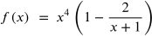. (Structure then action)

Example 3. Find the equations of the tangent lines to the graph of at x = -1.

Homework
HR: #’s 3, 7, 11, 15, 19, 25, 33, 39, 49, 61, 65, 75, 87, 93, 103, 105
Reduced work: Pick 8 - be sure to work in all of the different sets of directions and different functions.

Ch 2: Differentiation
Section 3 Day 3: Product & Quotient Rules & Higher Order Derivatives
Objective(s)
Academic…you will be able to: | Social Emotional…you will:
- Find the derivative of a function using the Product and Quotient Rules.  - Find the derivative of a trigonometric function.  - Find a higher order derivative.  - Particle motion | - Respect all in the classroom.  - Be ready to learn and participate.  - Persevere.
Homework Questions?🤷

Example 4. The position of a particle as it moves along a line is given by s(t) = t² = 5t + 24, where s is measured in inches & t is measured in seconds.
- Find the domain of the function.

- Find the displacement of the particle during the first 3 seconds. (displacement = the difference from the star position and end position).

- Find the average velocity of the particle during the first 6 seconds.

- Find the instantaneous velocity when t = 6 seconds.

- When does the particle stop? Move left? Move right?

- Find the average acceleration over the first 6 seconds.

- Find the acceleration when t = 6 seconds.

- When does the particle speed up? Slow down?

- Find the total distance traveled by the particle.

Homework
HR:115, 116, 121, 123, 124 (for 123 & 124 also find the average acceleration over the first 6 seconds), 127, 142 - 144
Reduced work: Pick 6 - be sure to work in all of the different sets of directions and different functions.

Game Day - you don’t have access
Ch 2: Differentiation
Section 4 Day 1: The Chain Rule
Objective(s)
Academic…you will be able to: | Social Emotional…you will:
- Find the derivative of a composite function using the Chain Rule.  - Simplify the derivative of a function using algebra.  - Find the derivative of a function involving the natural logarithmic function. | - Respect all in the classroom.  - Be ready to learn and participate.  - Persevere.
Homework Questions?🤷

Warm Up:
Let each of the following be an example of a composite function, h(x) = f(g(x)) where f(x) is considered to be the outside function and g(x) is considered to be the inside function. Find each f(x) and g(x) that make up the composite function h(x).
h(x) = (3x - 4)³ h(x) = e^{-3x} h(x) = sin(4x) h(x) = $\sqrt{-x^{2}+x-7}$

The Chain Rule

Example #1. Let us find the derivative of h(x) = (3x - 4)³.

Example #2. Given h(x) = $\sqrt{-x^{2}+x-7}$, find h’(x).

Example #3. Find dy/dx given y = sin⁴(3x² + x)

Example #4. Find 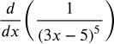

Example #5. Find the derivative of

Example #6. Differentiate the function 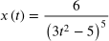.

Homework
HR: #’s 1, 7, 15, 19, 41, 43, 47, 105

Ch 2: Differentiation
Section 4 Day 2: The Chain Rule
Objective(s)
Academic…you will be able to: | Social Emotional…you will:
- Find the derivative of a composite function using the Chain Rule.  - Simplify the derivative of a function using algebra.  - Find the derivative of a function involving the natural logarithmic function. | - Respect all in the classroom.  - Be ready to learn and participate.  - Persevere.
Homework Questions?🤷

Example 1. Find all the points on the graph of for which n’(x) does not exist.

Example 2. Find the derivative of .

Example #3. Find 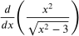.

Example #4. Find d’(x) given 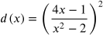

Homework
HR: #’s 23 - 33 odd

Ch 2: Differentiation
Section 4 Day 3: The Chain Rule
Objective(s)
Academic…you will be able to: | Social Emotional…you will:
- Find the derivative of a composite function using the Chain Rule.  - Simplify the derivative of a function using algebra.  - Find the derivative of a function involving the natural logarithmic function. | - Respect all in the classroom.  - Be ready to learn and participate.  - Persevere.
Homework Questions?🤷

Example #1. Find the derivative of y = tan(x² + 1).

Example #2. Find y’’(x) given e^{x/4}.

Example #3. Find the derivative of each function provided.
y₁ = cscx² y₂ = csc²x

Example #4. Find the derivative of f(t) = cos²(t³).

Natural Log Derivative
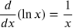

Example #5. Find the derivative of each.
f(x) = ln(2x³) g(x) = x²lnx h(x) = [ln(x + 5)]²

Example #6. Let h(x) = f(g(x)). Complete the table below such that h’(0) = 3 and h’(5) = -8.

x | f(x) | g(x) | f’(x) | g’(x)
-2 | 5 | 3 | -4 | 1
0 | 4 | 1 | 2 | b
1 | 6 | 5 | 1 | 4
5 | 15 | a | 3 | 2

Homework
HR: #’s 53 - 89 odd, 115, 123, 135, 163, 177

Tomorrow: Circuit Activity
Ch 2: Differentiation
Section 5 Day 1: Implicit Differentiation
Objective(s)
Academic…you will be able to: | Social Emotional…you will:
- Distinguish between functions written in implicit form and explicit form.  - Use implicit differentiation to find the derivative of a function.  - FInd derivatives of functions using logarithmic differentiation. | - Respect all in the classroom.  - Be ready to learn and participate.  - Persevere.
Homework Questions?🤷

Warm Up:

Explicit form: When y is in terms of x (like all of the functions you have worked with in your mathematical career).

Implicit form: When y is not in terms of x.

State whether or not the following equations are written in explicit or implicit form.

yx = 1 y = 1/x (x+y)(x-2)=3x² y = xy² - 4x y = cos(x)
Sometimes when we have an implicit equation, we can easily find an equivalent equation in explicit form. However…there are times when we can not easily (or at all) find an explicit form of an implicit equation. Thus…we have implicit differentiation!

Example #1. Evaluate each expression. Recall that y represents not a variable yet a function - y(x). Recall…when differentiating a function we need the chain rule.

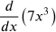 | 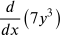 | 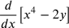 | 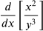
What are some guidelines for implicit differentiation…write these down if you like to have “steps”.

- Rewrite y as a function (if need be). Instead of y write y(x).
- Differentiate both sides of the equation with respect to the independent variable, mostly x.
- Collect all terms involving dy/dx on one side of the equation and move all other terms to the other side of the equation.
- Factor out dy/dx.
- Solve for dy/dx (in other words, get dy/dx alone).

Example #2. Find dy/dx given that 2y⁴ - y³x² + 4x³ = 5. We use the general steps above for this process.

Example #3. Determine the slope of the tangent line to the graph of 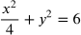 at the point .

Example #4. Find dy/dx given tan(xy)=3xy²

Homework…2.5
HR: 1 - 19 odd, 27

Ch 2: Differentiation
Section 5 Day 2: Implicit Differentiation
Objective(s)
Academic…you will be able to: | Social Emotional…you will:
- Distinguish between functions written in implicit form and explicit form.  - Use implicit differentiation to find the derivative of a function.  - FInd derivatives of functions using logarithmic differentiation. | - Respect all in the classroom.  - Be ready to learn and participate.  - Persevere.
Homework Questions?🤷

Example #1. If possible, represent y as a differentiable function of x. In other words, write the equation explicitly.
(x - 3)²+ y² = 1

Now, find dy/dx.

Find dy/dx of the original function. (x - 3)²+ y² = 1

What is the difference between these two derivatives? Which way did you find easier and why?

Example #2. Determine the slope of the graph of x^{2/3} + y^{2/3} = 5 at the point (8, 1).

Example #3. Given (x - 5)² + y² = 36, find d²y/dx² in terms of x and y only.

Example #4. Find the tangent line to the graph of (x + 2)² + (y - 3)² = 37 at the point (4, 4).

Homework 2.5
HR: #’s 25, 31, 33, 35, 43, 51

Ch 2: Differentiation
Section 5 Day 3: Implicit Differentiation
Objective(s)
Academic…you will be able to: | Social Emotional…you will:
- Distinguish between functions written in implicit form and explicit form.  - Use implicit differentiation to find the derivative of a function.  - FInd derivatives of functions using logarithmic differentiation. | - Respect all in the classroom.  - Be ready to learn and participate.  - Persevere.
Homework Questions?🤷

Example #1. Find the derivative of 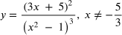.

Now…we could have taken the natural log of both sides above to help as well. Sometimes our prior knowledge can help us solve concepts in different ways because we can…and sometimes it is needed!

(HR only) Example #2. Let y = x^{x/4}. Find dy/dx. [how can we bring down the exponent so we can derive this?].

Example #3. Find dy/dx given tan(xy) = -2cos(x).

Homework 2.5
HR: #’s 53, 59, 61, 67, 81, 84 - 87

Game Day vs. U2 through section 5
2.6 Day 1: Derivatives of Inverse functions
You will be able to:
- Find the derivative of an inverse function.

Theorem: Continuity and Differentiability of Inverse Functions

Let f be a function whose domain is an interval I. If f has an inverse function (f passes the horizontal line test), then the following statements are true:

If f is continuous on its domain, then f ⁻¹ is continuous on its domain.
If f is differentiable on an interval containing c, and f’(c) ≠ 0, then f ⁻¹ is differentiable at f(c).

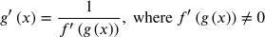
The Derivative of an Inverse Function
Let f be a function that is differentiable on an interval I. If f has an inverse function (f passes the horizontal line test) g, then g is differentiable at any x for which f’(g(x)) ≠ 0.

Where does the above come from? Well…when we think about inverse functions, we know that
f(f⁻¹(x)) = x
and if we let f⁻¹(x) = g(x) then
f(g(x)) = x
When deriving this we have to use the chain rule and we obtain
f’(g(x))*g’(x) = 1
Get g’(x) alone and the result is
g’(x) = $\frac{1}{f '(g(x))}$

*We must also keep in mind that inverse functions, most simply stated, are when the independent variable (x) is switched with the dependent variable (y). Thus, If f(a) = b then f’(b) = a or g(b) = a. This is very important to recall!

Example #1
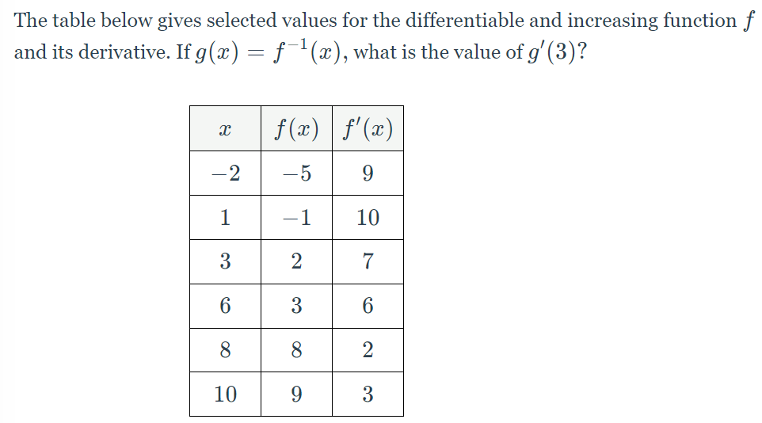

Example #2
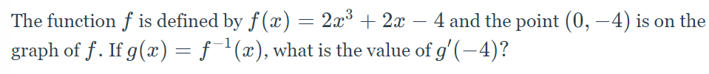

HW: 2.6 #’s 1 - 13 odd, 70, 85
2.6 Day 2: Derivatives of Inverse functions
Objective: You will be able to find the derivative of inverse trig functions.

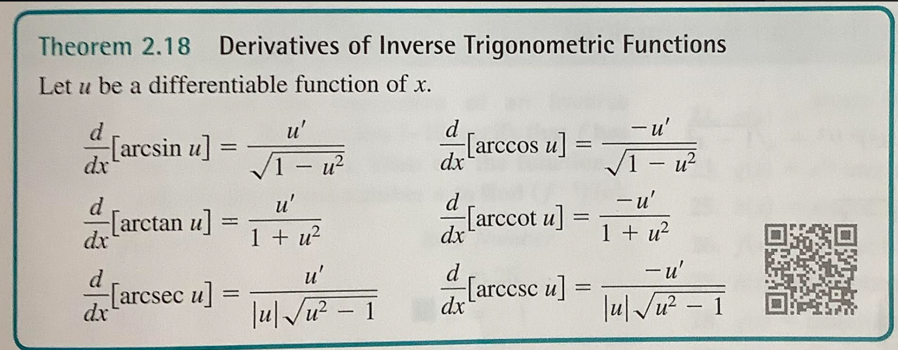

Example #1
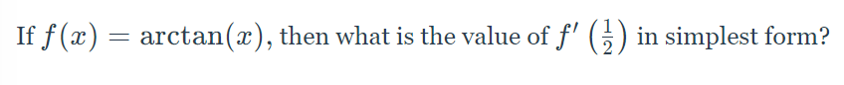

Example #2
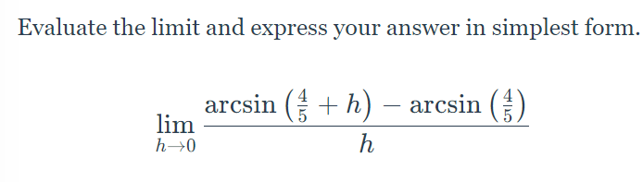

Example #3

Homework: 2.6 #’s: 15, 19, 45, 61

2.7: Related Rates
Day 1

Objective(s) You will be able to:
- Understand what a related rates problem entails
- Understand the notation of related rates
- Set up a related rates problem with all important information
- Solve related rates problems with proper units.

Warm Up
Assume that x and y are both differentiable functions of t and find the required values of dy/dt and dx/dt.

dy/dt when x = 2 & dx/dt = 3 dx/dt when x = 4 & dy/dt = 9
Equation: y = 5x² - 4x

Related Rates: Problems that involve two or more quantities and their corresponding rates of change with respect to time. The relationship between these quantities is used to express their related rates in terms of the other quantities’ known rate of change.

Let us walk through a few examples together.

Example #1:

Example #2
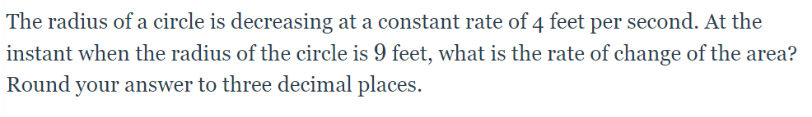

Example #3
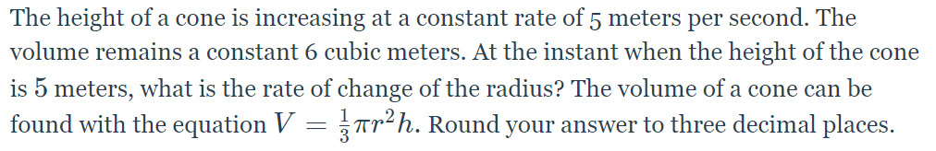

Example #4
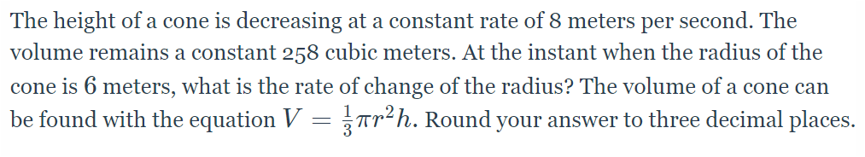

Example #5
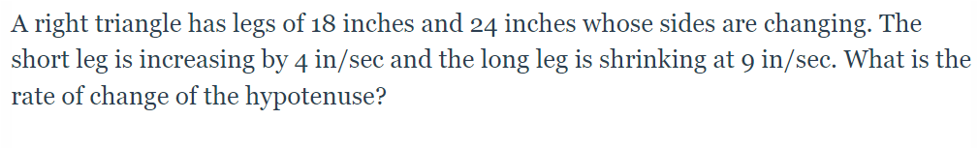

Homework
2.7 #’s 3, 7, 11, 13, 15

2.7: Related Rates
Day 2

Objective(s) You will be able to:
- Understand what a related rates problem entails
- Understand the notation of related rates
- Set up a related rates problem with all important information
- Solve related rates problems with proper units.

Example #1: A spherical balloon is inflated at a rate of 10m³/min. Find the rate at which the surface area of the balloon is increasing when the radius of the sphere is 3m.

Example #2: A conical cup is 4cm across and 6cm deep. Water leaks out at the bottom at a rate of 2cm³/sec. How fast is the water level dropping when the height of the water is 3 cm?

Example #3: A person standing at the end of a pier is docking a boat by pulling a rope at the rate of 2 m/s. The end of the rops is 3m above water level. How fast is the boat approaching the base of the pier when 5m of rope are left to pull in? Assume the rope is attached to the boat at water level.

Example #4: A person 2m tall walks towards a lamppost on level ground at a rate of 0.5 m/sec. The lamp on the post is 5m high. How fast is the length of the person’s shadow decreasing when the person is 3m from the post?

Example #5:
An airplane flies at an altitude of 5 miles toward a point directly over an observer. The speed of the plane is 600 mph. Find the rates at which the angle of elevation is changing when the angle is (a) 30⁰, and (b) 60⁰.

Homework
2.7 #’s 17, 19, 22, 23, 27, 35

Extra Practice
- If each edge of a cue is increasing at the constant rate of 3 cm/sec, how fast is the volume of the cube increasing when the length x, of an edge is 10 cm?
- If the surface area of a sphere is shrinking at the constant rate of 0.1 cm²/h, find the rate of change of its radius when the radius is $\frac{20}{π}$cm.
- In a rectangle with a diagonal 15 cm long, one side is increasing at the rate of $2\sqrt{5}$cm/s. Find the rate of change of the area when the side is 10 cm long.
- A girl flies a kite at a height of 30 m above her hand. If the kite flies horizontally away from the girl at the rate of 2 m/s, at what rate is the string being let out when the length of the string released is 70 m?
- Water is flowing into a vertical cylindrical tank of diameter 6 m at the rate of 5 m³/min. Find the rate at which the depth of the water is rising.
- Sand is being poured onto the ground forming a conical pile whose height equals ¼ of the diameter of the base. If the sand is falling at the rate of 20 cm³/sec, how fast is the height of the sand pile increasing when it is 3 cm high?



